PHYSICS PP2 FORM 3 MARKING SCHEME
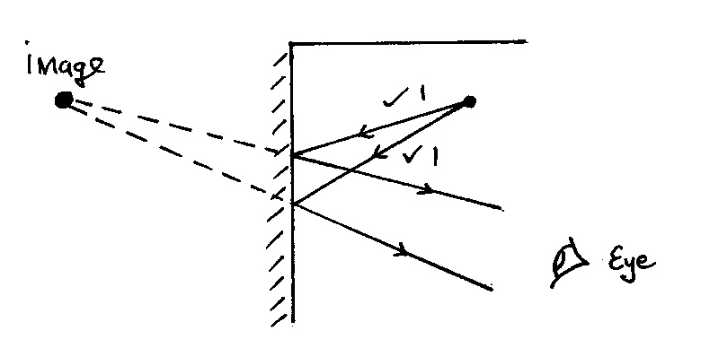
- (a)

(b) It forms multiple images that overlap.
2. i. For even distribution of charge.
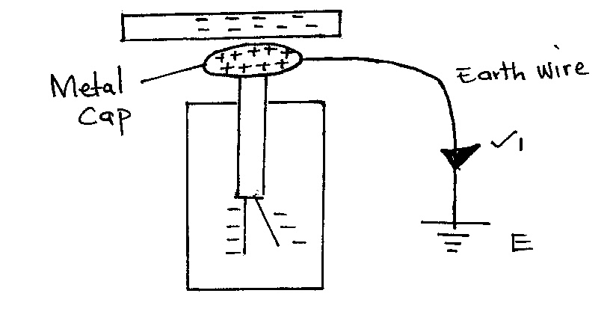
(ii)

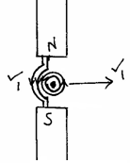

4. - Nail is hammered in North - South direction.
- Earth’s magnetic field aligns dipoles of the nail in one direction.
5. Produces an - Upright image.
- Magnified image
6. -Polarization – using a depolarizer e.g. potassium dichromate.
- Local action – pure zinc/amalgamation
7. i)-Same size as the image
- Same distance from the mirror as the object.

ii) Concave mirror Plane mirror
- Inverted - Upright
- Real - Virtual
8. i) Induction method
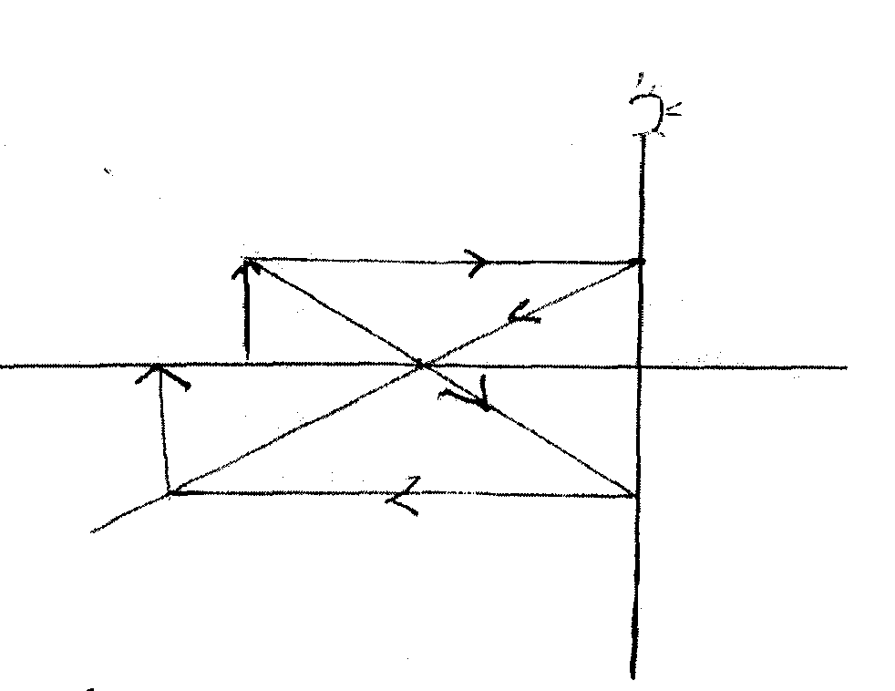
ii) Earthing to neutralise positive charges

9.

- Q = It
= 0.8 x 6 x 60C
∴Q = 288C
- V = 2d.
t
500 x 2 = 2(x – 500)mk
2.5 5.5
- = 1600 M
- A: mixture of carbon and manganese IV oxide
B: ammonium chloride solution/jelly
SECTION B
- (i)Maximum distance from rest position.or Maximum distance from mean position.
b)(i) amplitude=2
ii) T=2s
iii)ƒ = = 0.5
V = ƒλ
340 = 0.5 ×λ
λ =
(iv) - High density.
- Low temperature.
iv) Transverse waves-particle vibration of particles is perpendicular to direction of wave travel
Longitudinal waves-particle vibration of particles is parallel to direction of wave travel

- (a) (i)η =$\frac{1}{\sin{C}}=\frac{1}{\sin{42}}=1.4945$
1.4945=$\frac{\sin{60}}{\sin{r}}$
r = 35.42 º
(ii)η = $\frac{velocity in air}{velocity in glass}$
1.4945= $\frac{3x{10}^{8}}{velocity in glass}$
Velocity in glass= 2.0074 x 10⁸ m/s
(b) η = $\frac{r.d}{a.d}$
η =$\frac{30}{20}=1.5$

(c) Light must travel from denser medium to less dense medium.
        - Angle of incidence in the denser medium must be greater than critical angle in the less dense medium.

(d) (i) sin i = n
sin r

sin 30⁰ = 1.618
sin 18⁰
n = 1.618

(ii) sin C = 1
n
sin C = 1
1.618
C = sin⁻¹ 0.61804
C = 38.17⁰

15. (a) (i) A point on the principal axis at which rays parallel and close to the principal axis appear to diverge after reflection.
(ii) A real image is formed when real rays of light meet but a virtual image is formed when rays of light appear to meet but do not actually meet.

U(cm) | 20 | 25 | 30 | 35 | 40 | 45
V (cm) | 60.0 | 37.5 | 30.0 | 26.3 | 24.0 | 22.5
^{I}/_{U} cm⁻¹ | 0.05 | 0.04 | 0.033 | 0.029 | 0.025 | 0.022
^{I}/_{V}cm⁻¹ | 0.017 | 0.027 | 0.033 | 0.038 | 0.042 | 0.044
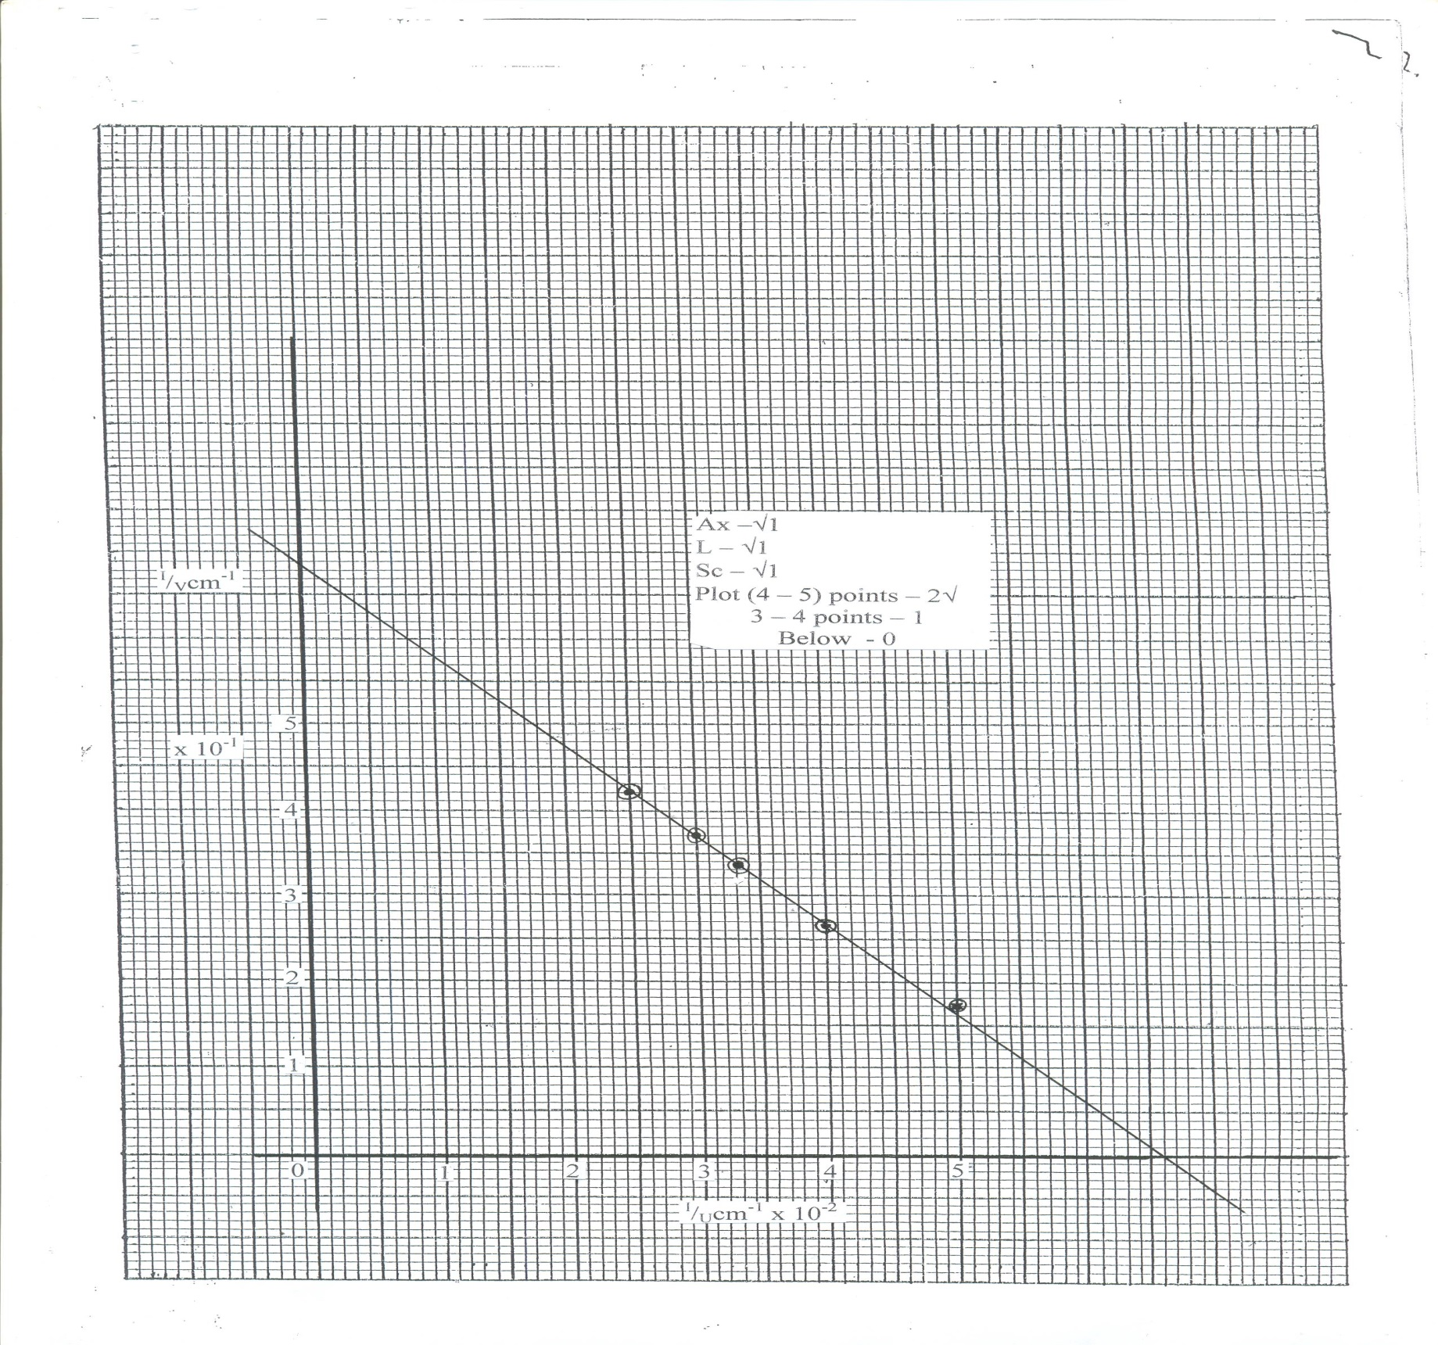
(ii) X &Y – intercepts = 6.6 + 0.1 cm⁻¹
^{I}/_{f} = ^{I}/_{U} + ^{I}/_{v} when ^{I}/_{u} = 0
then ^{I}/_{f} = ^{I}/_{u}^{I}/_{f} = 1
6.6 x 10⁻²
= 15.15cm
Focal length = 15.15 (15.0 – 15.16)

- (a)i) Soft iron1 since it is easily magnetized and demagnetized.
ii) - Increasing the amount of current 1
- Increasing the number of turns on the coil1

  - X:……..SOUTH Y:…….NORTH

(c)The direction which a free North pole would move if placed at that point in the magnetic field;√

(d) – Directional property
- Magnetic poles
e. Repulsion occurs only for like poles
- Attraction occurs for both unlike poles ,and poles of a magnet and a magnetic material.
f. Steel is a material that takes long to be magnetized and retains its magnetism for equally a long time while soft Iron are easily magnetized and at the same , they lose their magnetism easily
g. Because as the current flowed through the steel bar the domains were being aligned in the same direction√1 hence magnetizing the steel bar. The strength of the magnet could not, Increases further since all the domains were aligned in the same direction hence magnetically saturated
h. 1. By hammering the magnet in an east –west direction
2. By heating and cooling the magnet

